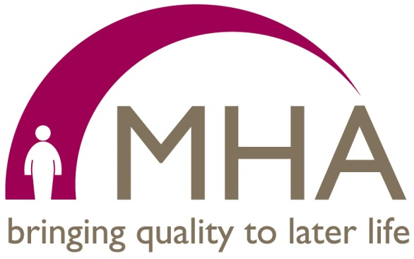

Hafan Y Waun – questions and answers for residents and relatives
In this document we have tried to cover as many of the most frequently asked questions we think you might have to the changes we are making at Hafan y Waun.
If you have a question which is not answered here, please contact Hazel Clement and we will endeavour to get the answer for you.

Why are you doing this?
This is not a decision we at MHA have taken easily as we know it will affect a number of our current residents.
The main reason we are closing the nursing unit is that, like the NHS and other nursing home providers, we are struggling to recruit nurses as there simply aren’t enough to fill the vacancies available both in Wales and England. This means that we may not be able to provide a safe service for our residents in the future. The nursing staff we have at the home are often having to work many extra shifts and we have agency staff travelling excessive miles to work at the home. In addition, the home manager has also been covering nursing shifts. This is unsustainable and we have to think about the safety of our residents first and foremost.
We have tried recruiting local and nationally, as well as in Eastern Europe but, regrettably, with little success.

What will happen to the residents now? Eight weeks to find another place isn’t enough time really, is it?
We recognise that this will be a difficult time for our residents, their relatives and friends. In this pack are full details of the nursing homes nearby and we will be supporting you during this time to make the decisions you need to make.
Details of local nursing homes, along with their latest inspection reports, are being provided to all relatives/residents to help them make the best choice of a new home for them. We will also provide support for the moves, such as the provision of a private ambulance where necessary.
Our experience recently of having to make a similar decision at another of our homes in 2015 because of difficulty in recruiting nursing staff has shown us the notice we have given is enough time. What we want to avoid is residents having a long period of uncertainty about their future home – experience has shown that eight weeks is the right amount of time for them to choose a new home with our help and support and to make that move.
There will be no nursing staff at the home after the date of closure of the nursing beds, therefore a new placement will need to be found before then.

What will happen to the nursing staff now?
Should our nurses wish to stay working for MHA, we will guarantee them a post at a nursing home within the organisation at a location of their choice at our other nursing care units. This will include providing them with a relocation package. If they chose to work elsewhere, we are confident that they will find employment due to their skills and expertise.

Is there another MHA home close by?
Unfortunately, the nearest MHA home is over 100 miles away in Penarth, near Cardiff, as is Frodsham in Cheshire. Should you wish to be considered for a placement at these locations or any other MHA nursing home we will ensure that this is given priority.

Is there an appeal process against the decision?
The decision to close the nursing beds at Hafan Y Waun was a difficult one and taken in full consultation with the Chief Executive. Because of our concerns over being able to provide safe care for our residents, it is a change which we have to make and, as such, there is no appeal process. We know this sounds harsh but the safety of our residents must come first.

What will happen to the unit once you close it?
The 20 nursing beds at Hafan Y Waun will be converted to residential care beds. This means that the care staff currently working on the nursing unit will be able to remain working at the home.

Are you doing re-assessments to see if residents can stay?
All the residents we believe could be affected will be re-assessed as to their needs by the local authority and local health board, along with ourselves.
Are you not able to recruit nurses because you are not paying enough?
MHA does pay well when compared to others, and we do have enhanced rates at the home, as in other locations, in addition to a good benefits package. Therefore we don’t believe that salary is the real issue. We have, in other remote locations, increased salary in an attempt to attract staff but it was not successful. We have tried several other initiatives to support recruitment and retention at HYW:
- We introduced the clinical nurse lead position to offer career development and to recognise responsibility,
- We sourced and provided assistance with relocation and accommodation in the town helping the nurses who did come with setting up tenancy agreements and even being landlord ourselves for some time.

