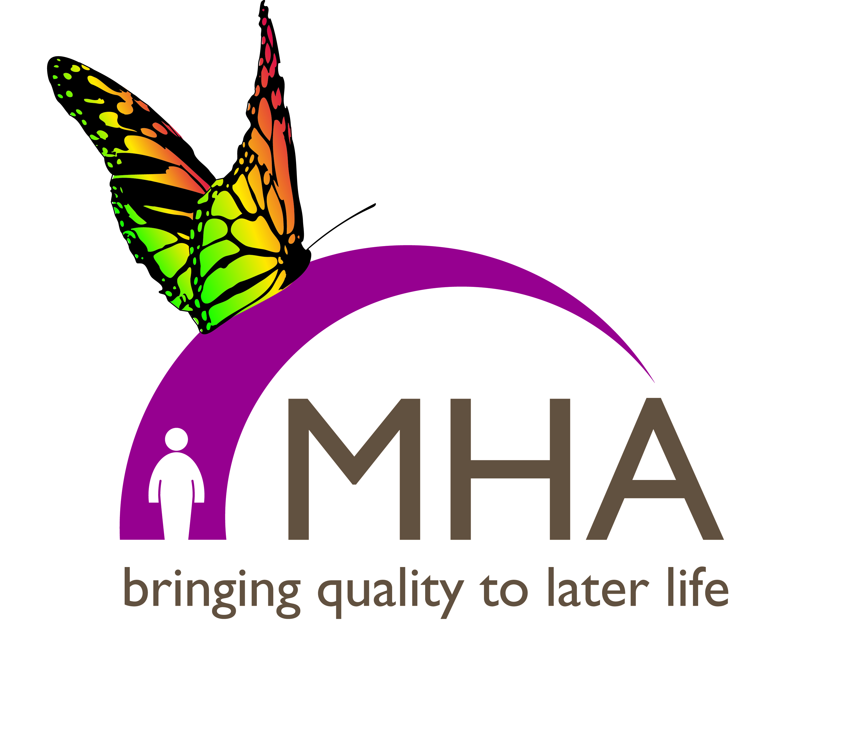**Welcome to November’s news and prayers from MHA.**

The first couple of weeks of this month are all about remembering and being remembered. Whether it is Saints or Souls, Guy Fawkes or the victims of warfare, I suspect almost everyone has someone they will be remembering. As you will see below we are holding our Gift of Thankfulness Service this month and in many of our care homes and housing with care schemes we hold an annual service at this time of year to remember those residents who have died during the past year, inviting back family and friends to take part. They are moving occasions and offer a reminder that care does not end abruptly when a person dies.

**Prayer**

*God of the seasons, as the days shorten and the nights get longer, we pray your blessing on all who mourn. In these days of remembrance, grant them peace and comfort, and the assurance that in you all life finds its end and new beginning.*

*“After darkness, light; after winter, spring; after dying, life: Alleluia! Amen.” (Fred Pratt Green)*

*“We need to rediscover we belong to one another and strangely enough, in that being together, the presence of God is found.”*

**Revd Prof. Frances M. Young**

A member of the Chaplaincy team told me recently, when reflecting on her time at MHA, “I joined MHA with the idea that I would be doing something good and charitable to people in need. I very quickly discovered that they are doing things for me.” This same thought was considered in more detail at our “Where Is My Older Neighbour” conference last month by the Venerable Christopher Skilton. If you would like to listen to his keynote address, and view some of the other speakers’ presentations, then click on this link: <http://www.mha.org.uk/get-involved/events/where-my-older-neighbour1/>

**Prayer**

*Lord, help us to see each other, regardless of our abilities or age, with the same scrupulous divine attention that Jesus does. Guide our communities so that we are able to reflect that gaze in its reverence to each person, so that each one of us is encouraged and helped to return that gaze with others.* ***Amen.***

During November we will be particularly remembering the following MHA services:

St Andrew’s Court, East Kilbride Wesley Court, Edinburgh

Taransay Court, Glasgow Auchlochan, The Retreat

MHA Jersey/Guernsey Auchlochan, Nethanvale

Auchlochan, Bankshouse, Lower Johnshill Lawnfield House and Court, Willesden

Riverview Lodge, Kingsbury David’s House, Harrow

Kenbrook, Wembley

We ask for God’s blessing on everyone involved in the above projects, particularly remembering those who are sick or troubled, and for the family and friends of those who have died.

**Prayer**

*Lord of time and space,*

*of eternity and each moment,*

*we pray for the on-going work of Methodist Homes.*

*May the gifts we offer encourage the skills of care and compassion*

*which demonstrate the values of respect and dignity,*

*and embody our belief that each person is of worth*

*and every moment precious.*

*For you assure us that your love is everlasting*

*and promise that you will be with us to the end of the age.*

***Amen.***

*When the one we loved has gone,*

*when death brings tormented peace,*

*as emotions swirl around,*

*sorrow mingled with release –*

*God of patience, bear our pain;*

*turn us back to life again.*

**Marjorie Dobson**

MHA’s annual [**Gift of Thankfulness Service**](http://www.mha.org.uk/get-involved/events/gift-thankfulness-service/) takes places this month, on **Sunday 2nd November, 3.00pm-4.00pm at the Church of Christ the Cornerstone, Milton Keynes**. This is a service to remember all those who have left legacies or gifts in memory to the work of MHA and all are welcome. Many of our homes and schemes also come together as a community to give thanks for the lives of those who have died in the last year. Sue Stilwell, Chaplain at Tremworths, says “It is a lovely opportunity for remembrance and thanksgiving and also for relatives and friends to return, many of whom may not have been here since the death of their loved ones. As the relatives come together, alongside staff members some of whom would have cared for their loved ones, we are awakened to the importance of the special bond between staff, residents and families.”

**Prayer**

*Loving God, we thank you for the bond of love that binds together each of us in our communities.*

*We thank you that it is through your love that we can care for others in our homes.*

*As we all come to this time of year when we remember those who have gone before, let us rejoice that they now rest in eternal peace with you.*

***Amen.***

Wishing you every blessing



Rev. Dr. Keith Albans

Director of Chaplaincy & Spirituality

**Your comments and feedback are always very welcome!  If you have any problems viewing this email or if you  have any comments on the news or prayers please** [**get in touch**](mailto:Rachel.walker@mha.org.uk?subject=EPFeedback) **– or, if you’d rather not receive the E-Prayer in future, you can let us know that too; just** [**click here**](mailto:rachel.walker@mha.org.uk) **to unsubscribe.  Thank you!**